**AWS Challenge**

* Launch one **EC2 instance** using **Amazon Linux 2**.

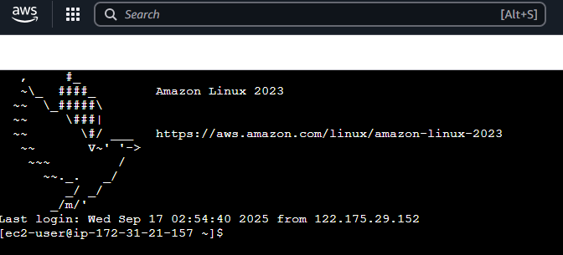

* Install **Apache**.
* **Steps to Install Apache (httpd) on Amazon Linux 2023**

1. **Update system packages**
2. sudo dnf update -y
3. **Install Apache (httpd)**
4. sudo dnf install httpd -y
5. **Enable and start the Apache service**
6. sudo systemctl enable httpd
7. sudo systemctl start httpd
8. **Check Apache status**
9. systemctl status httpd

You should see it running (active (running)).

1. **Adjust firewall (if needed)**  
   If you’re using firewalld, allow HTTP/HTTPS:

(On AWS EC2, instead make sure your **Security Group** allows inbound traffic on port 80 (HTTP) and 443 (HTTPS).)

1. **Verify Apache**  
   Open your browser and go to:
2. http://<your-ec2-public-ip>
3. You should see the Apache **Test Page**.

**🔹 Default paths on Amazon Linux 2023**

* Document Root: /var/www/html
* Config File: /etc/httpd/conf/httpd.conf
* Logs: /var/log/httpd/

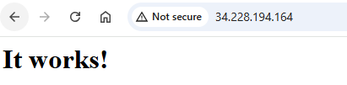

* Install **Nginx**.

**Steps to Install Nginx on Amazon Linux 2023**

1. **Update system packages**
2. sudo dnf update -y
3. **Install Nginx**
4. sudo dnf install nginx -y
5. **Enable and start the Nginx service**
6. sudo systemctl enable nginx
7. sudo systemctl start nginx
8. **Check Nginx status**
9. systemctl status nginx

It should show active (running).

1. **Allow HTTP/HTTPS traffic**
   * If using AWS EC2, make sure the **Security Group** allows inbound traffic on:
     + 80 (HTTP)
     + 443 (HTTPS) if you need SSL
2. **Verify Nginx**  
   Open your browser and go to:
3. http://<your-ec2-public-ip>

You should see the **Nginx default welcome page**.

**🔹 Default paths on Amazon Linux 2023 (Nginx)**

* Document Root: /usr/share/nginx/html
* Main Config: /etc/nginx/nginx.conf
* Site Configs: /etc/nginx/conf.d/
* Logs:
  + Access: /var/log/nginx/access.log
  + Error: /var/log/nginx/error.log

⚡Pro tip: To serve your own site, replace /usr/share/nginx/html/index.html with your custom file or create a new config in /etc/nginx/conf.d/.

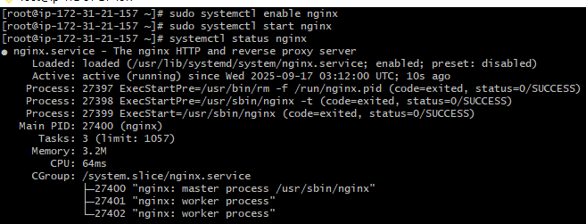

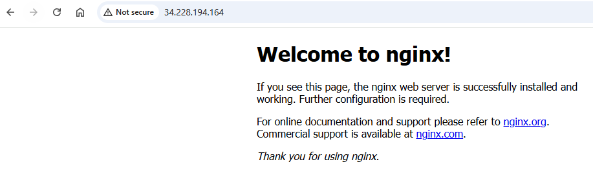

Install **Apache Tomcat**

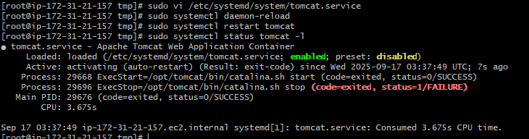

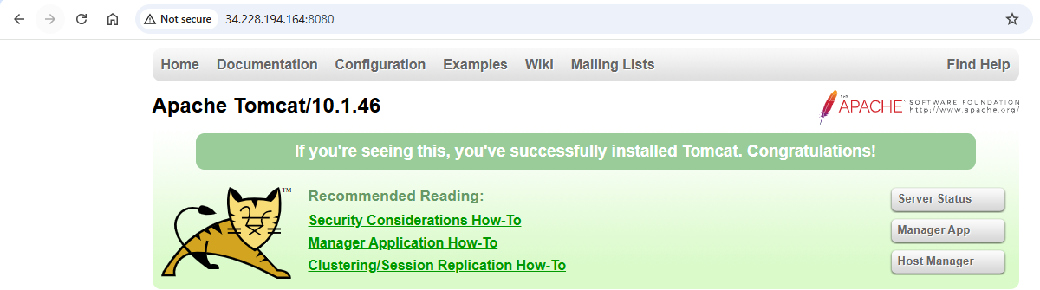

* Install **Jenkins**.

Verify:

java -version

## **2️⃣ Install Jenkins**

Add the official Jenkins repository:

sudo dnf install wget -y

sudo wget -O /etc/yum.repos.d/jenkins.repo \

https://pkg.jenkins.io/redhat-stable/jenkins.repo

sudo rpm --import https://pkg.jenkins.io/redhat-stable/jenkins.io-2023.key

sudo dnf install jenkins -y

## **3️⃣ Configure Jenkins port**

Create the config file if it doesn’t exist:

sudo nano /etc/sysconfig/jenkins

Paste:

# Jenkins configuration

JENKINS_PORT="8080"

JENKINS_LISTEN_ADDRESS="0.0.0.0"

JENKINS_USER="jenkins"

JENKINS_HOME="/var/lib/jenkins"

## **4️⃣ Ensure Jenkins home exists and has proper permissions**

sudo mkdir -p /var/lib/jenkins

sudo chown -R jenkins:jenkins /var/lib/jenkins

sudo chmod -R 755 /var/lib/jenkins

## **5️⃣ Fix systemd service (clean setup)**

Create/overwrite the service file:

sudo nano /etc/systemd/system/jenkins.service

Paste:

[Unit]

Description=Jenkins Continuous Integration Server

After=network.target

[Service]

Type=simple

User=jenkins

Group=jenkins

Environment="JENKINS_HOME=/var/lib/jenkins"

Environment="JENKINS_PORT=8080"

ExecStart=/usr/bin/java -jar /usr/share/java/jenkins.war --httpPort=${JENKINS_PORT}

Restart=on-failure

[Install]

WantedBy=multi-user.target

## **6️⃣ Reload systemd and start Jenkins**

sudo systemctl daemon-reload

sudo systemctl enable jenkins

sudo systemctl start jenkins

sudo systemctl status jenkins -l

* Should show Jenkins **active (running)**.

## **7️⃣ Update EC2 Security Group**

* Allow inbound **TCP port 8080**.
* Source: 0.0.0.0/0 (or your IP for security).

## **8️⃣ Access Jenkins**

Open in browser:

http://<EC2-Public-IP>:8080

Get the initial admin password:

sudo cat /var/lib/jenkins/secrets/initialAdminPassword

